CPower controller 4G protocol

Transcoding description:
The following process is done sending and receiving low-level functions, If you write your own PC side of the sending and receiving programs, you must implementation as below conventions. Use the without transcoding code to calculation checksum.

Send：
Between start code and end code, if there is 0xA5, 0xAA or 0xAE, it should be converted to two code：
0xa5 ➔ 0xaa 0x05。The purpose is to avoid the same with the start character 0xa5
0xae ➔ 0xaa 0x0e。The purpose is to avoid the same with the end of the symbol 0xae。
0xaa ➔ 0xaa 0x0a。The purpose is to avoid the same with the escape character 0xaa。

Receive：
Received symbol 0xa5, said that the beginning of a packet
Received symbol 0xae, said that the end of a packet
When PC receive data from controller, if there is 0xA5, 0xAA or 0xAE, it should convert two code to one code, specifically for
0xaa 0x05 ➔ 0xa5
0xaa 0x0e ➔ 0xae
0xaa 0x0a ➔ 0xaa

Communication mode
GPRS communication is UDP communication.
4G communication is TCP communication.

Controller devide ID:
GPRS is a string composed of a 6-30 pure digits.
For example: 123456, 1234567890, 13548796352.

4G string composed of a 13. (我们把网口MAC地址，化成长度12的十六进制格式化字符串。加上) .
For example: ID = 00606eb88d7f + 0
Hex ID = 30 30 36 30 36 65 62 38 38 64 37 66 00
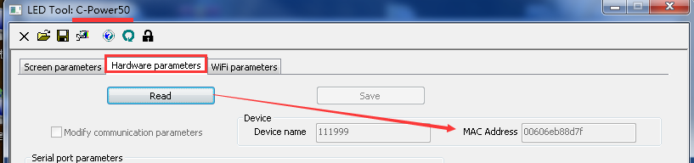

Heartbeat packet format:
Controller send heartbeat packet format: 0xA5 + controller device ID + 0x01 + 0xAE
GPRS server return packet format: 0xA5 + controller device ID + 0x91 + 0xAE
For example:
Controller device ID: 394612
Controller send heartbeat packet: A5 33 39 34 36 31 32 01 AE
GPRS server return packet: A5 33 39 34 36 31 32 91 AE

54A
Controller send heartbeat packet format:
0xA5 + controller device ID + 0x68 + 0x32 + 0xFF + 0xED + 0x01 + 0x12 + 0x00 + Heart rate count + SL + SH + 0xAE
心跳计数  Heart rate count | 0~255 | 1 | 取值0~255，含义如下：  0：控制卡上电后发送的第一个心跳包，待服务器返回心跳包确认（返回包中的心跳计数值为0）后开始计数；  1~200：心跳计数值，在没有发生异常的时候，控制卡按计数顺序发送心跳包，从1开始计数，计到200，再重新从1开始。  201~255：异常码，当控制卡发生异常情况后，发送异常码，待服务器返回心跳包确认（返回包中的心跳计数与异常码一致）后，再次从1开始计数发送。  各异常码含义如下：  255：控制卡连接断开，重新注册或者GPRS模块重新初始化  201~254：保留
server return packet format:
0xA5 + controller device ID + 0xE8 + 0x32 + 0xFF + 0xED + 0x01 + 0x12 + 0x01 + Heart rate count + SL + SH + 0xAE

For example:
MAC : 00606eb88d7f
Hex ID = 30 30 36 30 36 65 62 38 38 64 37 66 00
The first heartbeat packet sent by the control card:
A5 30 30 36 30 36 65 62 38 38 64 37 66 00 68 32 FF ED 01 12 00 00 99 02 AE
server return packet
A5 30 30 36 30 36 65 62 38 38 64 37 66 00 E8 32 FF ED 01 12 01 00 1A 03 AE

备注：服务器需要对控制卡的心跳包进行回应，给出返回包，当控制卡n=3次收不到返回包时则认为掉线，重新建立连接并发送注册包进行注册。

Registration package:
GPRS does not require a registration package.
4G requires a registration package

Controller send heartbeat packet format:
0xA5 + controller device ID + 0x68 + 0x32 + 0xFF + 0xED + 0x01 + 0x10 + Project name + 0x00 + password+ 0x00 + SL + SH + 0xAE
4G server return packet format:
Registration success
0xA5 + controller device ID + 0x68 + 0x32 + 0xFF + 0xED + 0x01 + 0x10 + 0x00 + SL + SH + 0xAE
Registration failed, device ID length is invalid
0xA5 + controller device ID + 0x68 + 0x32 + 0xFF + 0xED + 0x01 + 0x10 + 0x01 + SL + SH + 0xAE
Registration failed, control card name or password is incorrect
0xA5 + controller device ID + 0x68 + 0x32 + 0xFF + 0xED + 0x01 + 0x10 + 0x02 + SL + SH + 0xAE
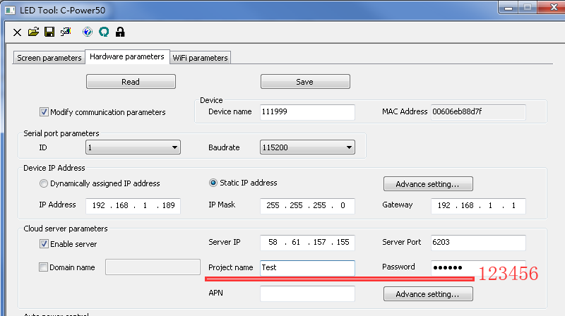
For example:
MAC : 00606eb88d7f
Hex ID = 30 30 36 30 36 65 62 38 38 64 37 66 00
Controller send heartbeat packet
A5 30 30 36 30 36 65 62 38 38 64 37 66 00 68 32 FF ED 01 10 54 65 73 74 00 31 32 33 34 35 36 00 6C 05 AE
备注：注册包的目的是让服务器判断连接上来的设备是否合法，当合法时，控制卡才有必要进行下一步动作，当不合法时，控制卡无需动作。
当控制卡没有收到服务器的注册返回包时，控制卡需要重复注册，直到收到返回包为止。一旦注册成功，就可以发送心跳包了。

Communication packet format:
GPRS server send communication packet format:
Controller return data packet format:
0 | 1 | 2 | 3
Start code | Controller device ID | Communication data | End code

Description:
Data | Value | Length(byte) | Description
Start code | 0xA5 | 1 | The start code of the packet
Controller device ID |  | Variable-length（6~30） | See Controller devide ID:
Communication data |  | Variable-length | Communication data:  The processing of data blocks need to be transcoded like that Transcoding description:  Communication data format is same as the original data format from “Packet type” to “Packet data checksum”.  See the file Basic Protocol of CPower LED Display Controller.doc and C-Power external calls communication protocol.doc
End code | 0xAE | 1 | The end code of the packet.

For example : Set time(CMD=0x47)
The Communication data format in the file Basic Protocol of CPower LED Display Controller.doc.
GPRS server send data packet:
A5
33 39 34 36 31 32
68 32 01 47 01 00 35 18 10 01 0C 0B 0C 64 01
AE
Controller return data packet:
A5
33 39 34 36 31 32
E8 32 01 47 01 01 35 18 B1 01
AE

